**Iteration 0**

**Team Roles**

The scrum master will be Apurva Shinde (with Leon Liu taking over duties if she is unavailable) and the product owner will be Edmund Do.

**Customer Meetings**

The weekly customer meeting is set to be on Tuesdays at 7pm CT, for a maximum of 15-30 minutes for each team member (while the product owner may stay a bit longer assuming the customer has more detailed needs).

**Summary**

The customer needs an automated system to manage the guest lists for events he/she creates for invited guests, as well as guests who decide to attend the events on their own. The system should combine the total count of confirmed guests (VIP guests and BOX office guests) so that it gives a clear picture to the event owner about the number of occupied seats and vacant seats depending on which he/she may strategize publicizing the event. The system should also enable tracking of referrals and incentivize appropriately with a reward system. Stakeholders in EventNXT are event organizers and managers who are responsible for ticket sales and seating arrangements thus ensuring that the event is successful.

The application meets the customer need by managing both – RSVPs from invited guests and box office sales data via a spreadsheet that is imported to the application and provides a ticket commitment inventory. The exclusivity of this system lies with its ability to combine both – RSVP and box office ticketing into one portal as previously designed systems managed only one of these at once. It also includes a feature for referral rewards which can be further enhanced. The customer is able to achieve the goal of managing event tickets, promotion strategies, and guest referrals by using this system.

**User Stories/Lofi Diagrams**

The following are five example user stories (represented by lofi diagrams) that we intend to try to implement in the first iteration:

| Feature: User can upload image to invitation card  As a user of the application  To add an image to the invitation card  So the image can be shared with those invited  Scenario: User uploads image  Given I am on the EventNXT event creation page  When I press “Add image from desktop”  Then the system’s File Explorer should open up  And when I select an image file to upload  The image will uploaded to the website  And the image will be on the event invitation card |
| --- |

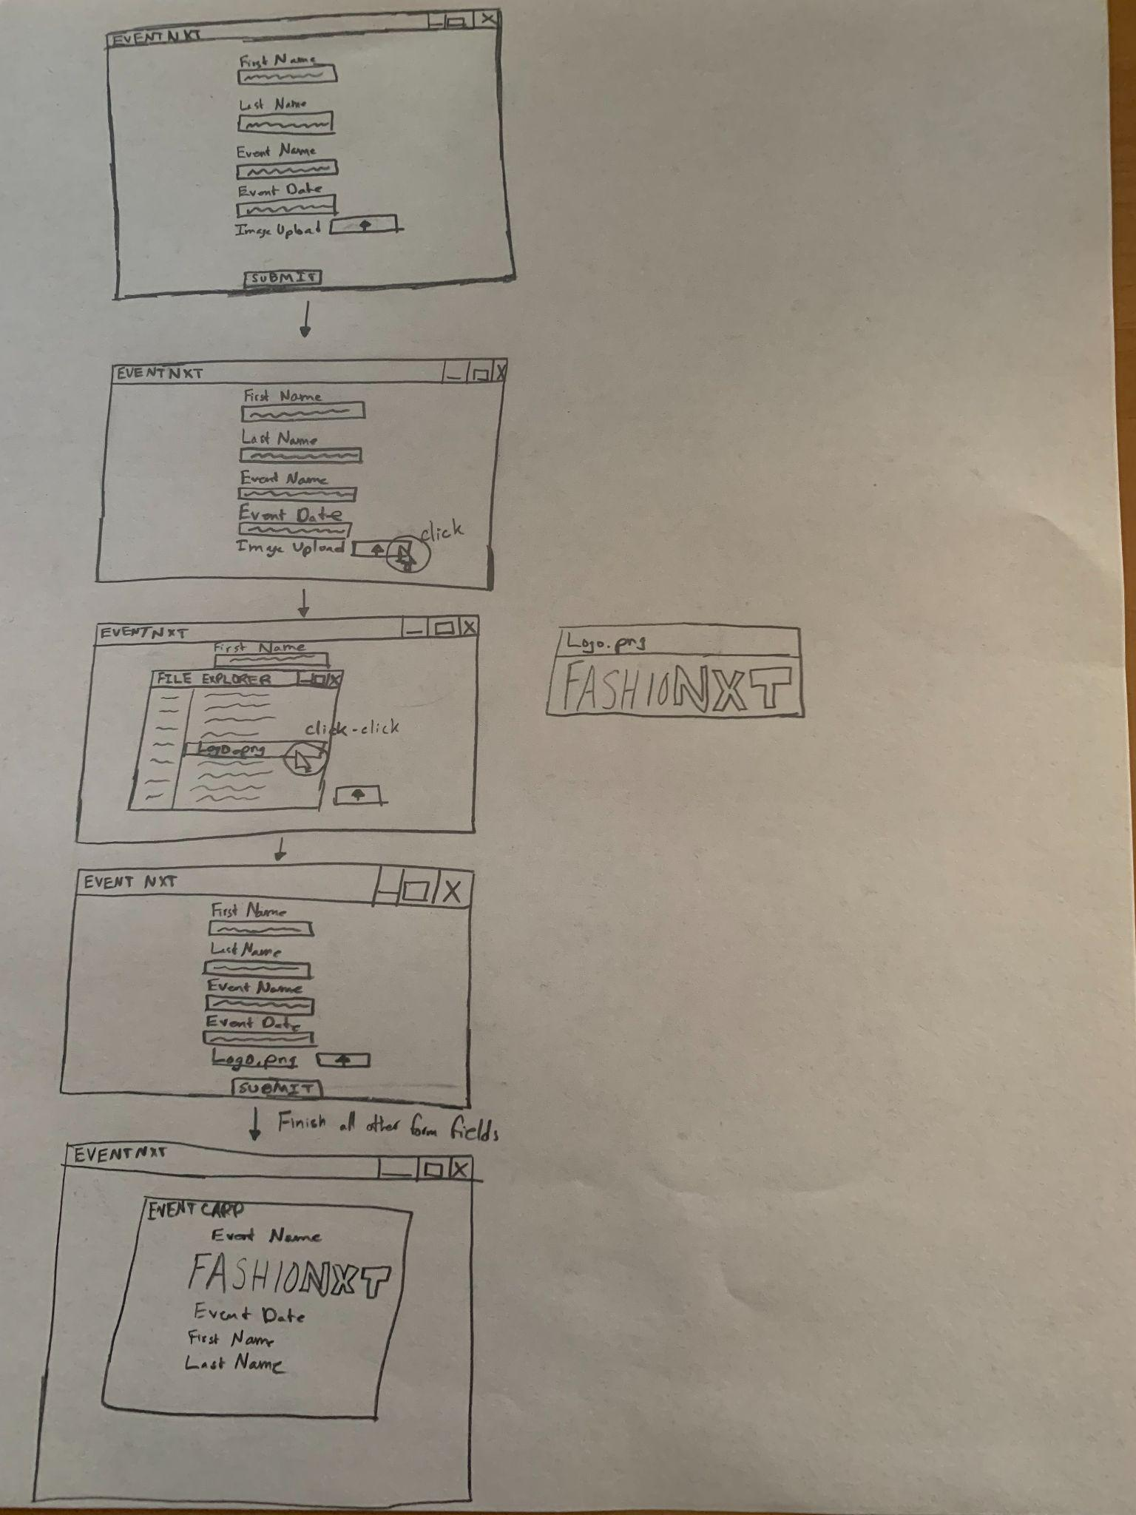

| Feature: User can send invitation card out via email  As a user of the application  To send the invitation card via email to those invited  So the invited can RSVP and be notified of the event  Scenario: User is on the Guest List page  Given that I am on the Guest List page with their email listed  When I click “Send” for the guest  Then the guest should receive the invitation card in their email |
| --- |

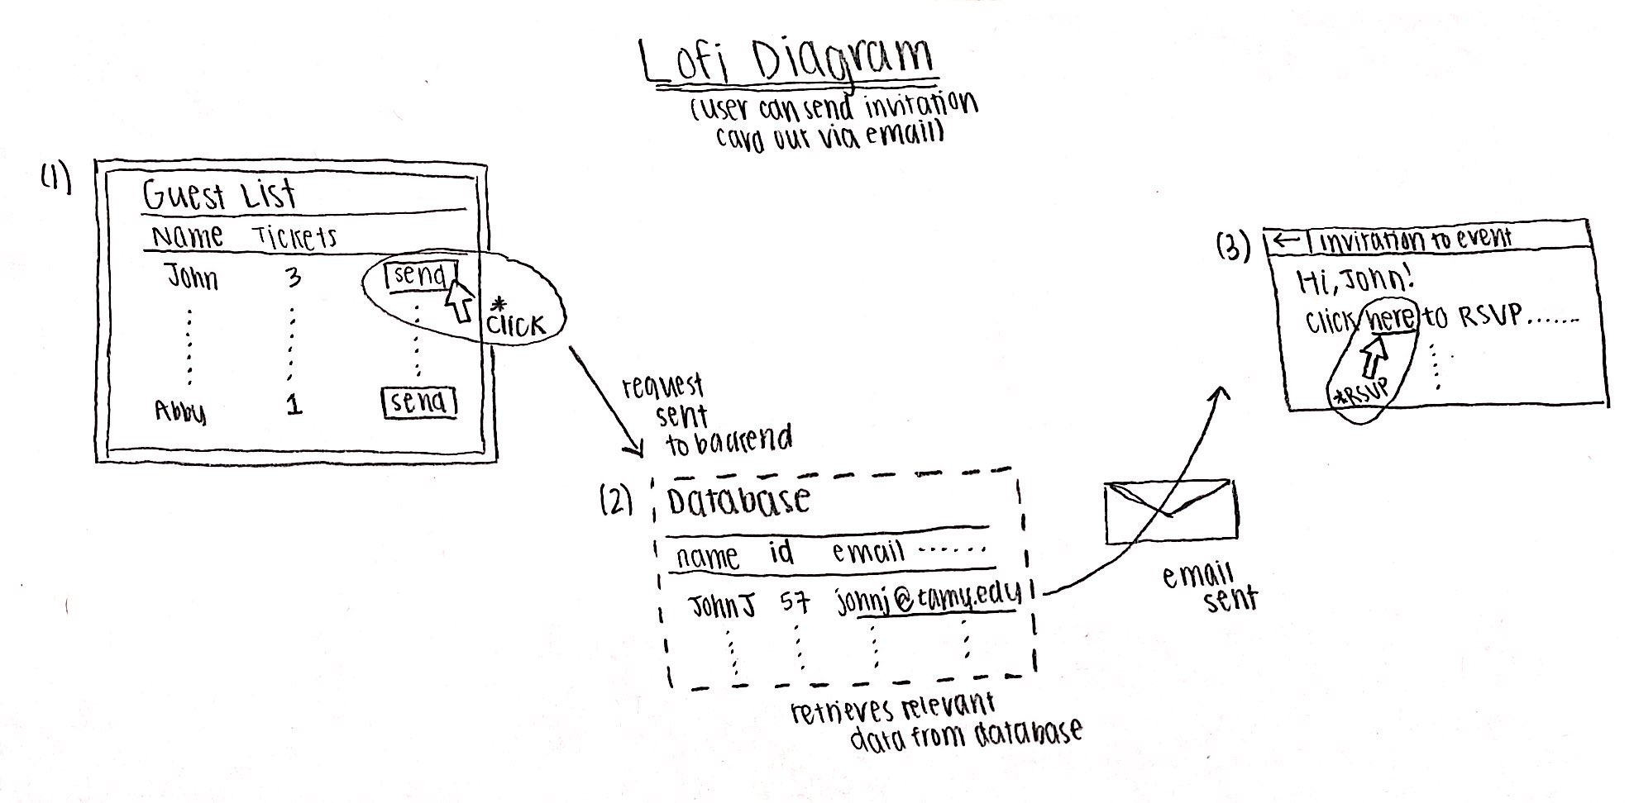

| Feature: User can input appropriate information for invitation card  As a user of the application  To correctly input appropriate information  So the user can be notified if information entered is invalid  Scenario: Validation for the information user inputs  Given that I am on the registration page  When I a user enter his/her details  The details should be validated |
| --- |

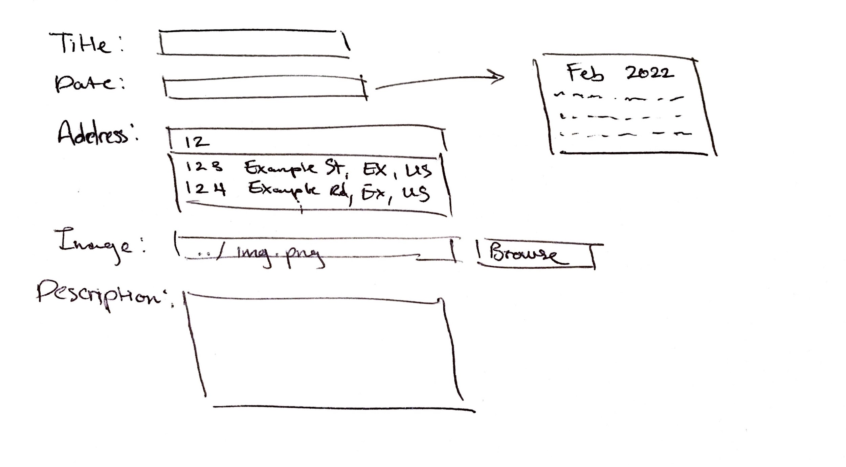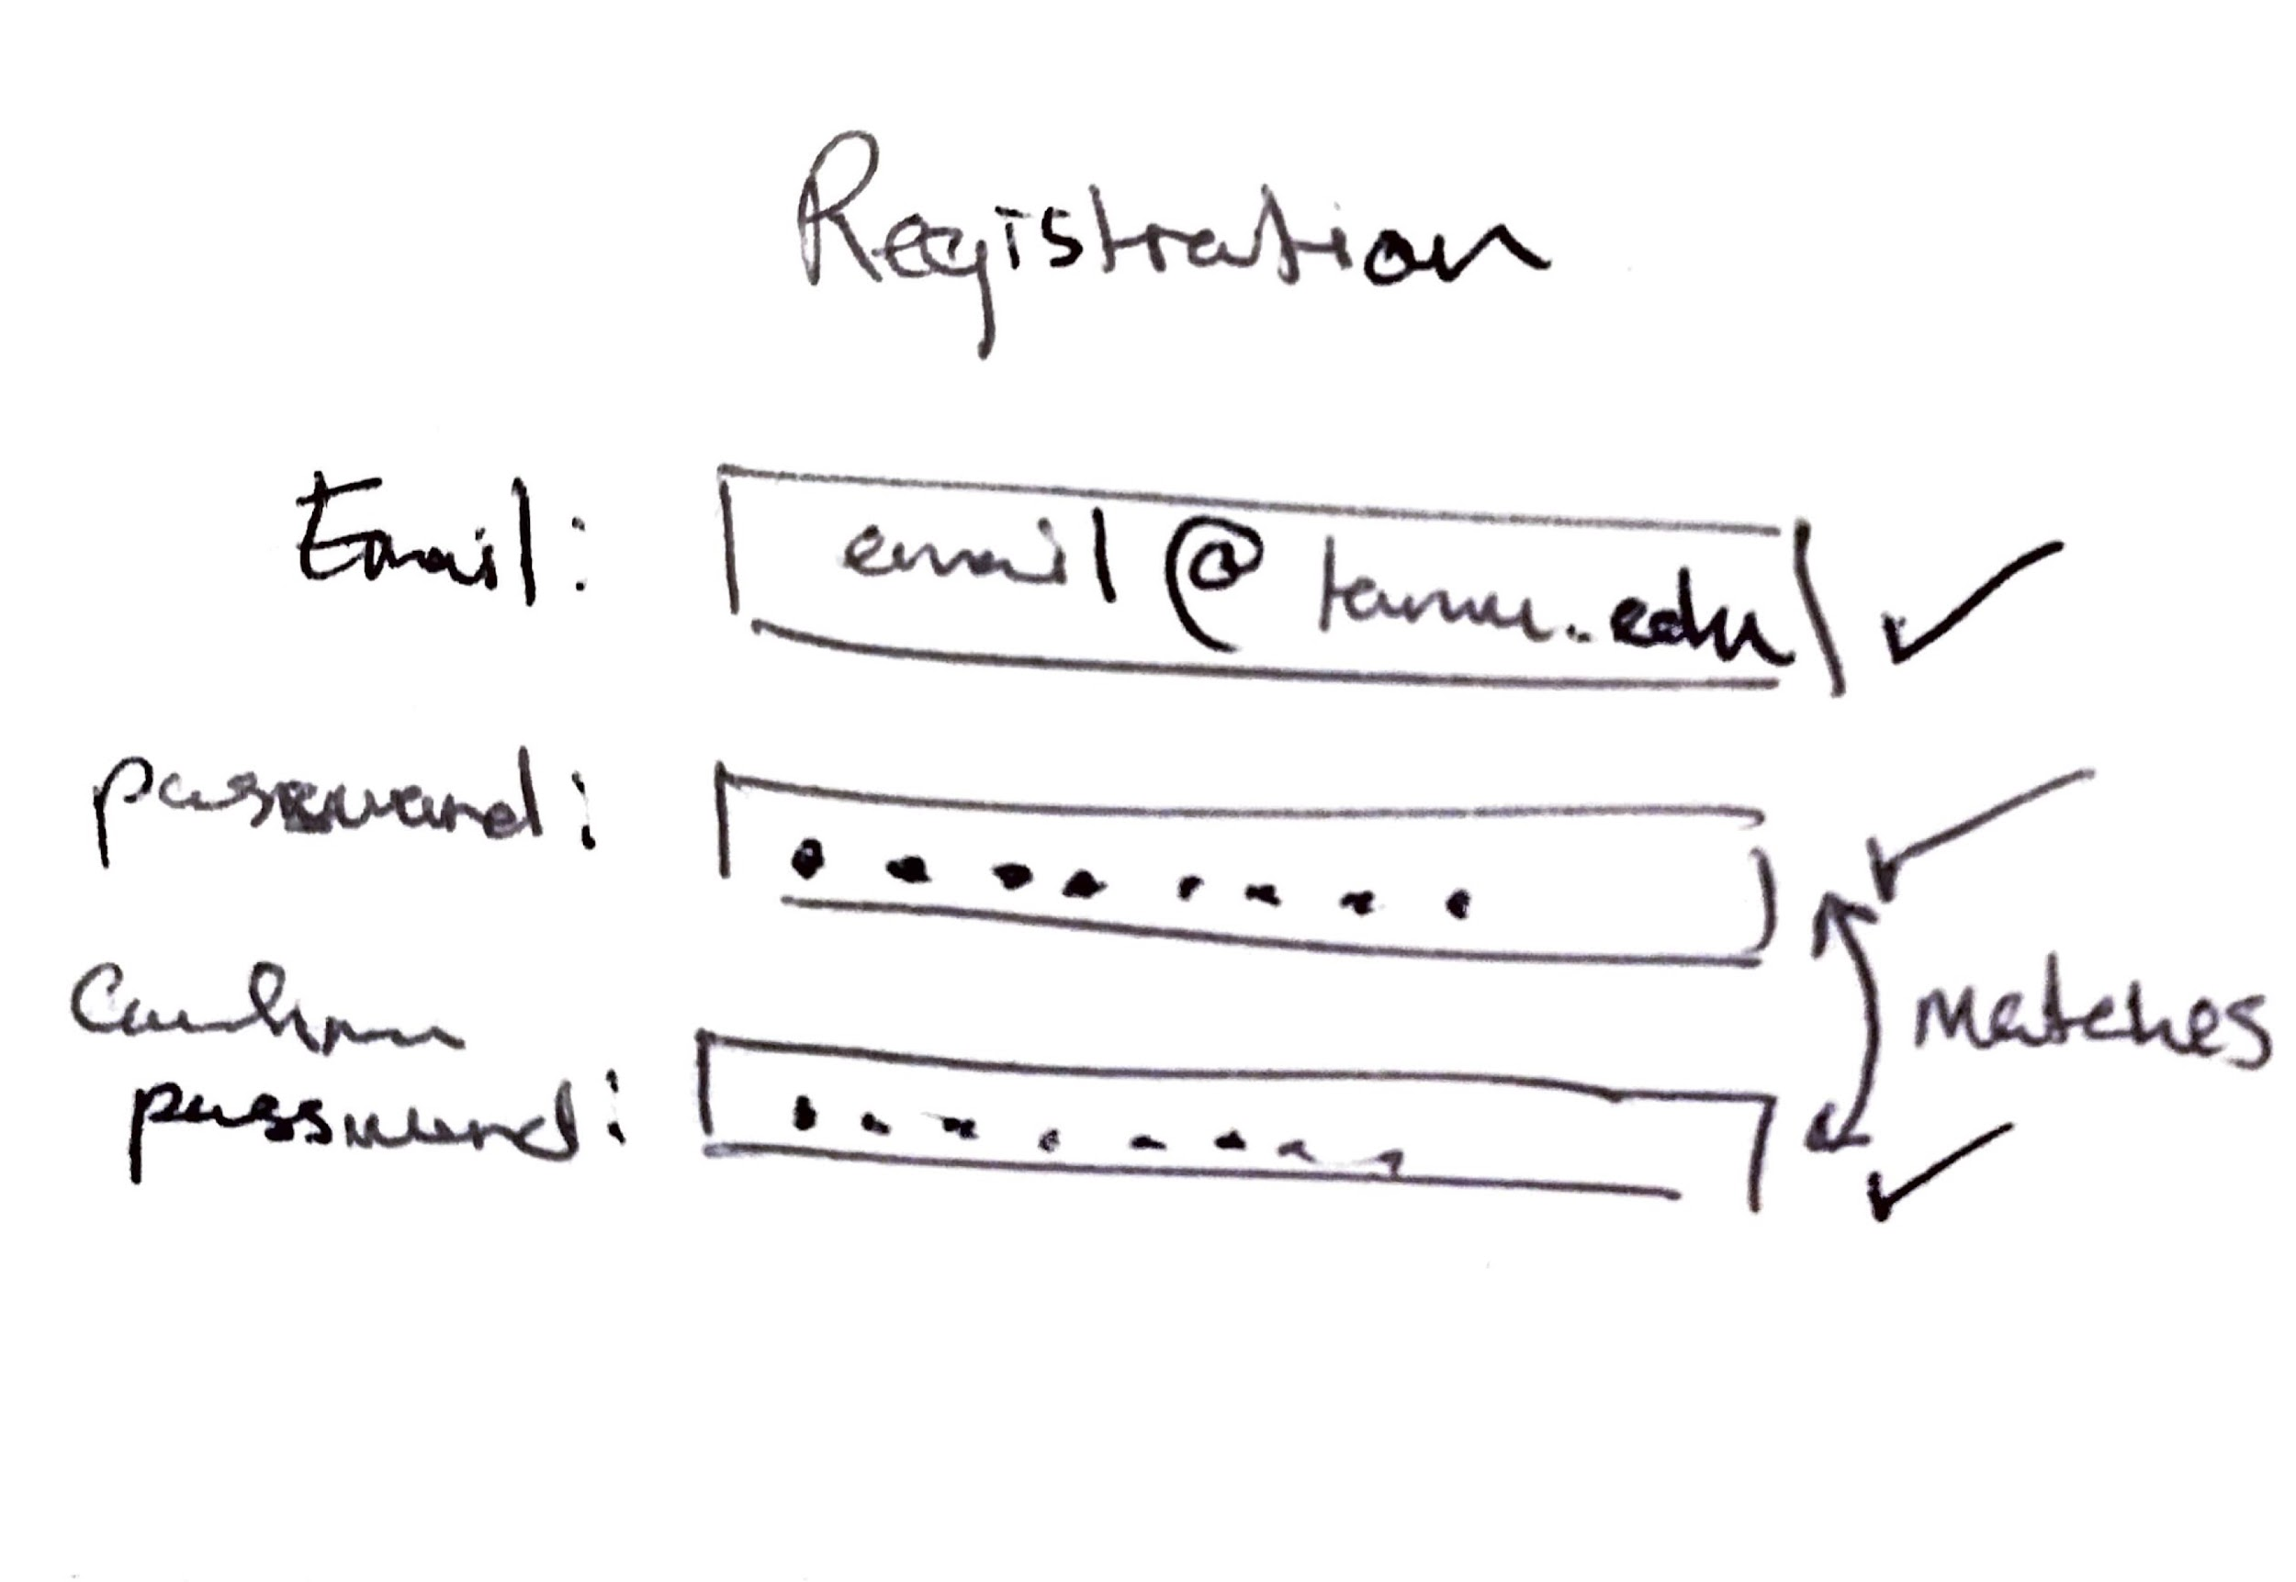

| Feature: User can fill in address for invitation card (Apoorva/Apurva)  As a user of the application  To have an option to fill in the address for the invitation  So an invitee can be notified of the address of the event Scenario: User fills in form for invitation card  Given that I am on the user invitation form  And I fill in the address  Then on submit, the address is on the invitation card preview |
| --- |

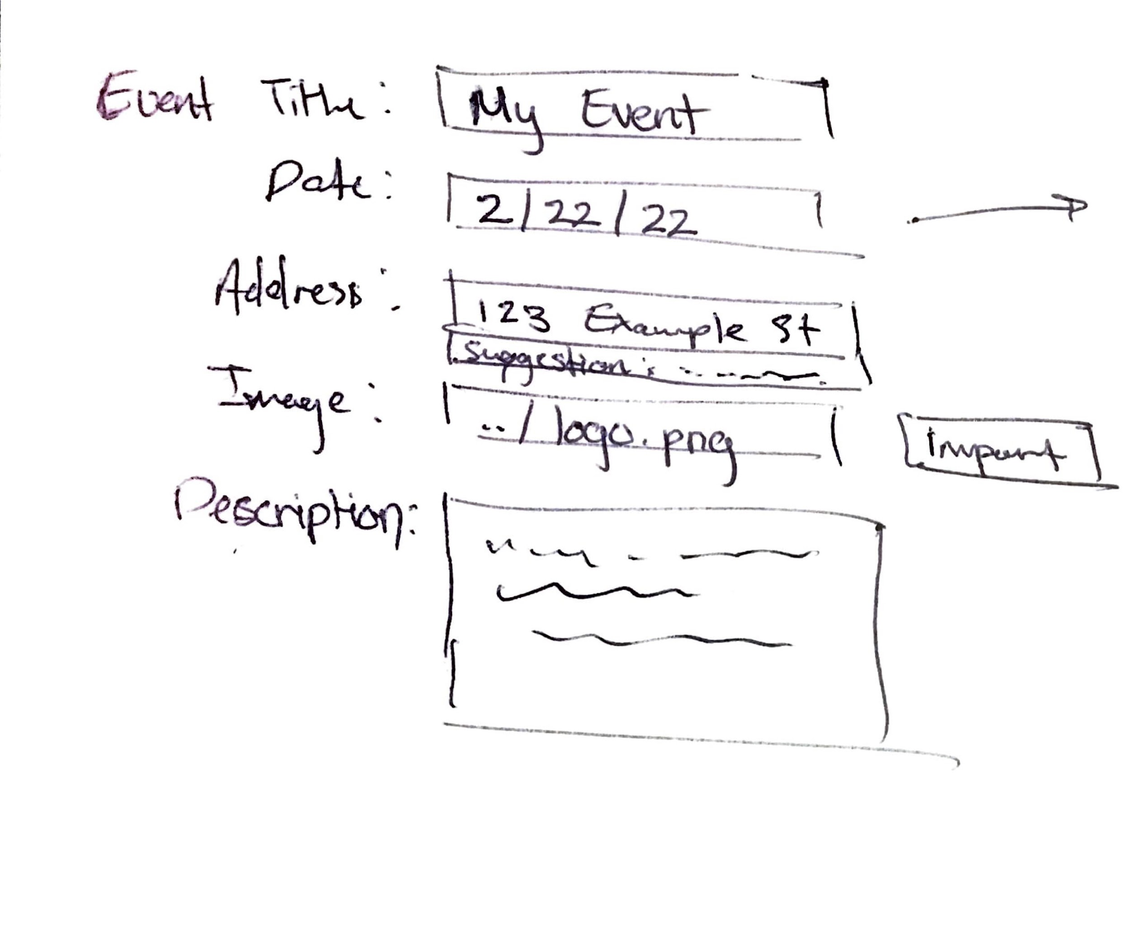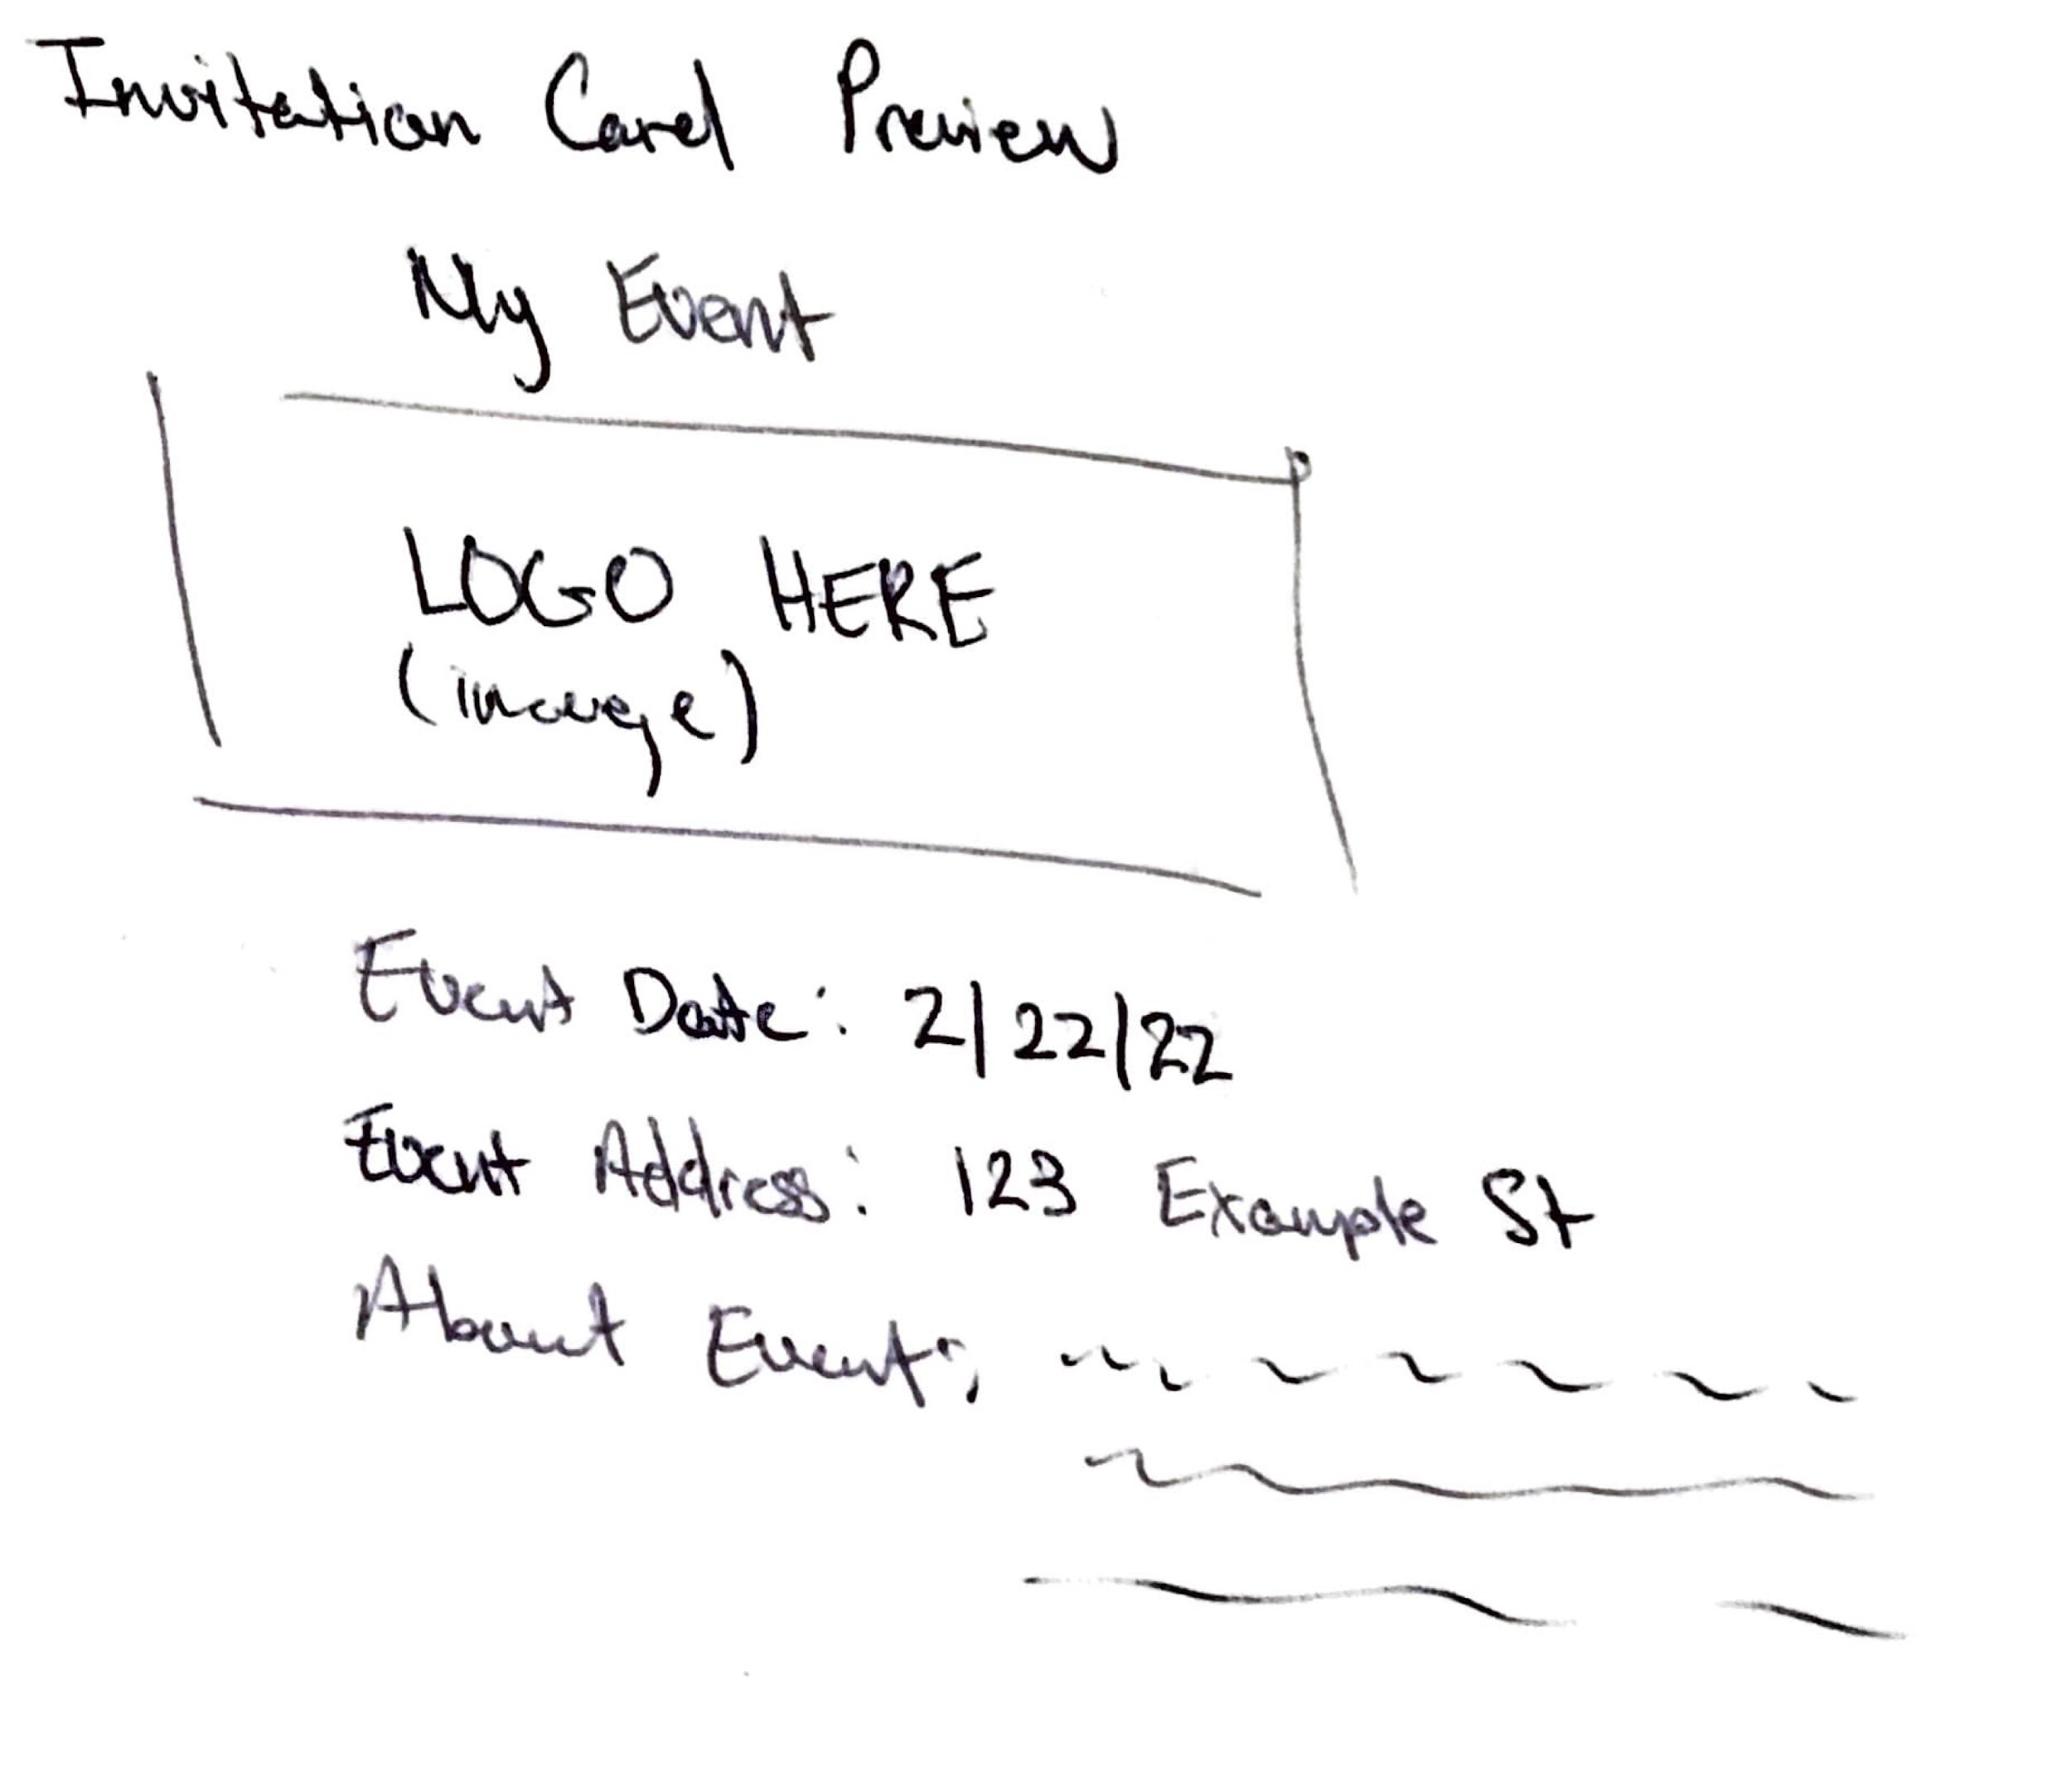

| Feature: User can easily make full event (Apoorva/Apurva)  As a user of the application  To have proper flow among all elements of event creation  So the user can easily use the application  Scenario: Creating all aspects of the event  Given that I am viewing the “Create Event” button  I can click on “Create Event” button  And fill out the event invitation information correctly  And the be taken to “Add Seating”  And the various seating tiers for the event correctly  And then be taken to the “Guest-List Table”  And then add appropriate information to add guests  And then import box office data that should be displayed on event page |
| --- |



**Improving Legacy Code**

The legacy code includes functionalities to combine both the BOX office sales and VIP sales while creating events. It also includes some basic functionality for offering rewards. It allows an event owner to create an event by adding in the event details like Name, Photo (currently broken), Address and also enables the owner to invite some guests via the VIP ticketing system. These VIP guests receive an email with invitation details created using the system and can RSVP with the confirmation details if they choose to attend the event. Attendants can purchase a number of tickets through the BOX office and refer friends/interested parties to get referral rewards. The confirmed seats for event/events are tracked in a combined spreadsheet automatically which gives the event owner an idea about the number of pending seats and booked seats. Finally, the system is expected to display real-time seat commitments to the owner so that he can strategize promoting the event and avoid over-committing ticket sales. Technically speaking, the site implements features that are essential to the core functionality of the application. This includes sign up and login, event creation, referral creation, and guest commitment management. However, the design of the site does not give a good user experience. There is a lot of jumping from page to page to get certain tasks done, which leads to unnecessary wait time for the page to change. In addition, some features did not feel cohesive. For example, while there is a “Create New Event” button, there is no record or ability to work on previous events. In addition, form fields do not perform any validation, and the event portal does not perform real time updates as changes are made to the guest list. There is also some functionality that was either broken or unimplemented, but it was not specifically documented. The only third-party integration is the email service using SendGrid. This service will have to be set up again for guests to receive invitation cards and referral links by email. Our goal for the project is to bring together the core functionality to yield a more cohesive and responsive design.

For this project the client expects the bugs in the existing code to be fixed along with giving a user-friendly experience to the event owner. He expects us to add validation checks which are currently missing while filling in the event details like valid address and contact details. Validation checks can be enforced on every field that the owner needs to fill. The photo upload option while creating an event is currently not working, which needs to be fixed. An email invitation is not getting sent to VIP guests when the event owner clicks on the send email button which needs to be fixed. There should be a fix to fit the email invitation on a single page which is currently elongated to multiple pages. The flow of the event creation steps needs to be optimized and the referral rewards functionality needs to be updated based on the discussion in the following meetings so that it is fair to the attendants. There is a need for proper itemization and categorization of seats so that the owner can identify empty boxes and promote accordingly. After the VIP invites are sent out, there needs to be a functionality to follow up on the responses received from RSVPs by allocating them seat types depending on availability and informing them accordingly. A proper tracking of referrals can be implemented and finally the payment processor can be enhanced.

**Pivotal Tracker/GitHub/Slack**

A pivotal tracker project called EventNXT was created and all collaborators were added. (<https://www.pivotaltracker.com/n/projects/2554870>)

A GitHub repository called EventNXT-606 was created with all the legacy code and all collaborators were added. (<https://github.com/jgmuir/EventNXT-606>)

A Slack channel called EventNXT ([https://eventnxt.slack.com](http://eventnxt.slack.com)) was created and all collaborators were added.

If the professor, TA, or grader is unable to access one of the above, please send us an email or message.

**Grading Approach**

A basic structured grading approach is fine.